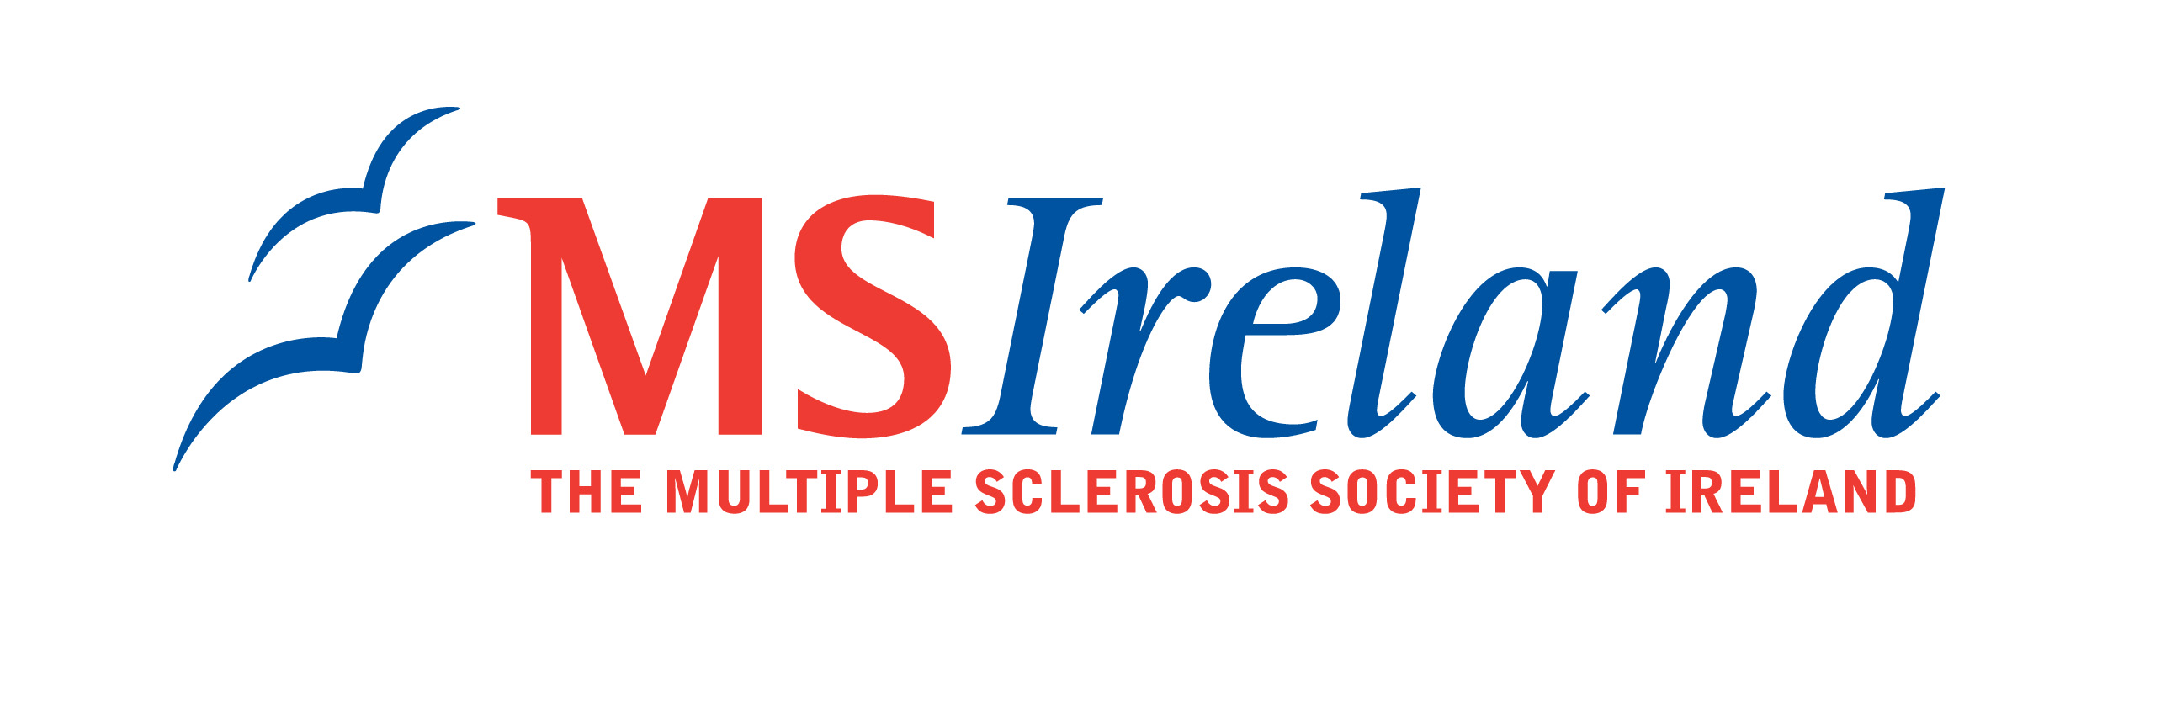

Interim Report
MS Ireland has provided funding for the project below and is delighted to publish interim results following:

Title: Investigating the role of IRAK-1, a novel negative regulator of type I interferon signalling in Multiple Sclerosis pathogenesis

Research Lead: Dr Marion Butler
Institution: National University of Ireland, Maynooth
Duration: 1 year

Summary Interim results:
The applicants are exploring the role of IRAK-1 in the pathogenesis of Multiple Sclerosis. The applicants will now be assessing the expression of IRAK-1 in immune cells from MS patients versus control patients. The applicants have been exploring the mechanisms underlying the ability of IRAK-1 to modulate type I interferon production and have made considerable progress towards understanding the mechanisms involved. The applicants intend to define exactly how IRAK-1 regulates type I interferon production and to clarify its role in MS.

