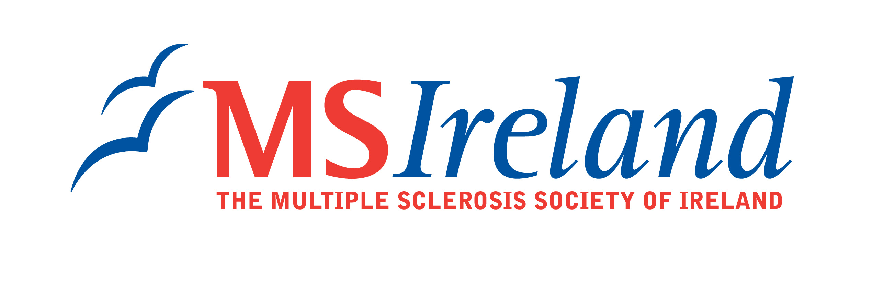

MS Ireland’s Medical Advisory and Research Committee has selected and the Board of MS Ireland has sanctioned the following research projects for funding in the 2009/2010 round of MS Ireland’s research programme.

Title: Investigating the role of IRAK-1, a novel negative regulator of type I interferon signalling in Multiple Sclerosis pathogenesis

Research Lead: Dr Marion Butler
Institution: National University of Ireland, Maynooth
Duration: 1 year

Description of project:
Interferon-β is currently being used with success in the treatment of patients with Multiple Sclerosis (MS). Our research is looking at a form of a protein that is not normally expressed in the brain but is seen with aging and inhibits the production of interferon-β. This research aims to determine if this protein is abnormally expressed in MS and in so doing further our understanding of the disease process. We are going to determine how this protein leads to the reduction of interferon-β and future work will look at how the activity and expression of this protein is controlled.

