**MS Irelands East Wicklow Branch**

**Autumn Newsletter 2021.**

* It is my absolute pleasure to open this branch newsletter by congratulating **Mairin Harris** as the **MS Person of the Year for 2021.** Following on Mairin’s coat tale is **Helen Binions,** who was **The MS Carer of the Year.** They are two very worthy winner’s, and I am sure everyone sends Mairin and Helen their very best wishes and heart felt congratulations.

. 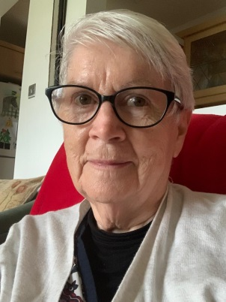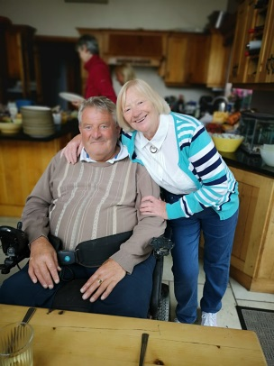

* The recent **Seeds of Hope-Wildflower Seeds** fundraising campaign was a huge success, making the branch almost c €3,060 with a net profit of €2,360 for much badly needed funds. It was so successful we are repeating it next February. (They are a sachet of wildflower seeds for just €3.) A big thank you to everyone who asked their local shops to participate.
* The branch held its annual **memorial service** at the Glenview Hotel recently, and it was extremely well attended – including the South Dublin Branch. A special thank you to Elsie for being an excellent MC on the day, Jo Leonard and the Greystones Folk Group and Father Gerry Young as celebrant.
* The Zoom Friday meet up group are holding their annual ‘Christmas lunch’ on Sunday, December 5th at 1pm in the Arklow Bay Hotel. To book your place please contact Damien Byrne on 087-414 9229. This year it will be held in a private room, the Asghard Suite, with a beautiful 4 course meal and contribution towards this will be €10 pp with EWB covering the rest.
* On the day we will be presenting Mairin and Helen with their much deserved awards.
* We are also holding a ‘Christmas raffle’ at the lunch and we are writing to companies looking for spot prizes for the raffle. Your help here would be greatly appreciated should you know any local companies who would be willing to donate a prize. Or if anyone has any unwanted gifts at home they would like to donate they would be gratefully accepted. Please contact Damien with regards this if you can help.
* The same group also meet for coffee on Thursday at the Bay Hotel. And their next monthly lunch is on Saturday, October 30th, again at the Arklow Bay Hotel. To join in either of these events, simply contact Damien at 087-414 9229.
* The latest covid information from national office we continue to send to branch members by email.
* The **2022 MS calendar** is available selling at just €6. The committee and branch members will again ask the local chemist and shops to sell them for the branch. This year the calendar theme has moved away from scenic pictures to original art, and they look superb. This is one of the main fundraising events for the EWB as there is no sign of flag days being resumed in the foreseeable future due to covid. For every calendar sold, the EWB makes €3. We have ordered an initial 600 calendars.
* Also, we have MS Christmas cards on sale at just €5 for a ten pack of individual cards. For further information here contact Mark by text on 087 2 453 193 or [mark.mitchell8@gmail.com](mailto:mark.mitchell8@gmail.com). The EWB make €2 per pack of cards sold.

Looking forward to seeing you at the next coffee morning at Bay Hotel, the monthly lunch and the December annual lunch.

**Mark Mitchell**

**Chair. MS Irelands East Wicklow Branch.**  **27/10/2021**