Tear out this letter to send to the Oireachtas members in your constituency and have your voice heard. If you have any personal details you would like to add in support of our ask, please feel free to write it in.

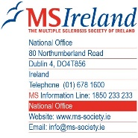

Re: Pre-Budget Asks of The Multiple Sclerosis Society of Ireland (MS Ireland)

Dear TD/Senator

My name is [blank]. I am writing to you to ask you to support the Pre-Budget Submission of The Multiple Sclerosis Society of Ireland.
MS Ireland has three primary asks for Budget 2023 which include:

An ask to increase annual statutory investment in The National MS Care Centre by €600,000
The National MS Care Centre is a 12 bedded unit which provides respite care to people living with Multiple Sclerosis and other progressive neurological conditions. MS Ireland are requesting €600,000 additional funding which would see The National MS Care Centre open 350 days per year, providing an additional 1,128 bed nights annually. The National MS Care Centre provides Centre provides people living neurological conditions, including Multiple Sclerosis, and their caregivers a break and delivers a range of therapeutic services, neurological assessments, and social activities.
Further investment will not only support people living with neurological conditions such as Multiple Sclerosis, but will also support voluntary carers, without whom care in the home would be impossible, relieving further pressure on our health systems and hospital funding.
An ask for sustainable funding for MS Ireland to deliver a national health promoting physical activity physiotherapy services for people with Multiple Sclerosis, and other neurological conditions total €880,000 per annum
Currently many people with progressive neurological conditions in Ireland have little or no access to rehabilitation services and are low priority for physiotherapy in primary care. There is a void of post-acute and post-community interventions to promote patients’ health through physical activity.

MS Ireland proposes a sustainable, specialist physiotherapy service to address this need using a blend of ‘online’ and ‘in-person’ programmes which provide a pathway of care from rehabilitation to community integration. Using data from a successful SláinteCare/Integration Fund project in the Mid-West, this evidence-based service will provide physiotherapist led, health promoting exercise for people with neurological conditions through a national physiotherapy service across all nine HSE CHOs.

MS Ireland have forecasted that this investment would annually deliver 1,458 participants in group programmes and 3,726 individual appointments and could be rolled out in one national development, or in phased regional stages.

An ask for the provision of a further 100 neurology nurses in order to address unacceptable waiting periods, delays with diagnosis and treatment, with at least 20 to be provisioned for in Budget 2023
MS Ireland as members of the Neurological Alliance of Ireland have been supporting the “Patients Deserve Better” Campaign which highlights the lack of neurology nurses across the country. Ireland requires further 100 neurology nurses in order to address unacceptable waiting periods and delays with diagnosis and treatment. Neurology nurses, including MS specialist nurses play a crucial role in the care of people living with neurological conditions. MS Ireland believes that all people living with Multiple Sclerosis should have appropriate access to an MS specialist nursing service.

As a member of your constituency, I am asking that you support MS Ireland’s asks as well as those of the Neurological Alliance of Ireland, The Disability Federation of Ireland and Family Carers Ireland in the upcoming Budget.

Yours sincerely,
[blank]

Testimonials:

"I found out about the online exercise programme through the MS society and found it suitable to where I was at. Because of Covid it was delivered on line and I found this excellent. I had no travelling and I engaged with others from all around the country. We shared stories, hints and tips and learned from each other experiences and differing journeys. Most importantly for me we had a laugh. Through everyone's’ sharing and openness I gained valuable knowledge about falls, risks, and how to minimise them and since I completed the course my walking has improved considerably. My advice to anyone considering the programme would be to give it a try, I think you’ll be surprised at the difference it can make." Paschal

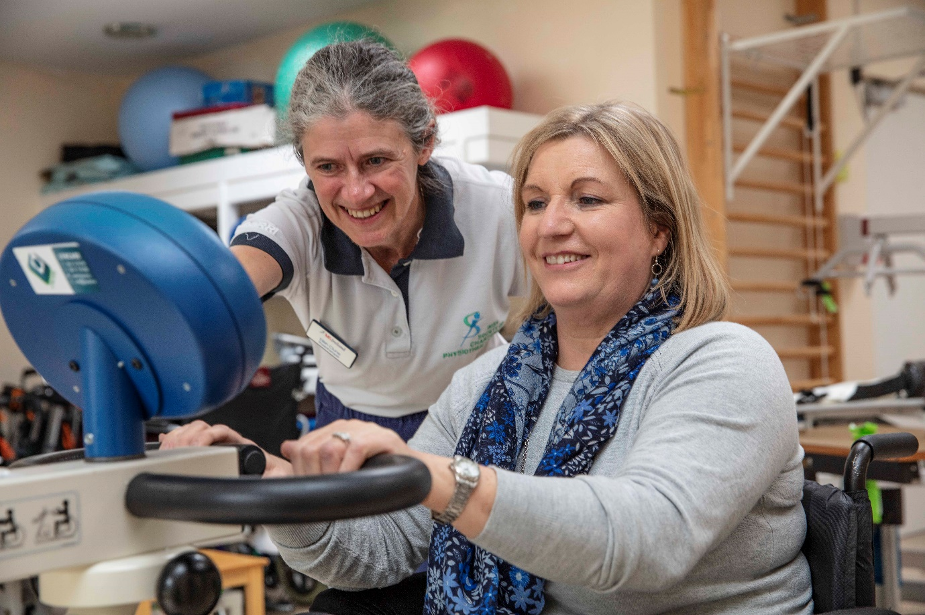

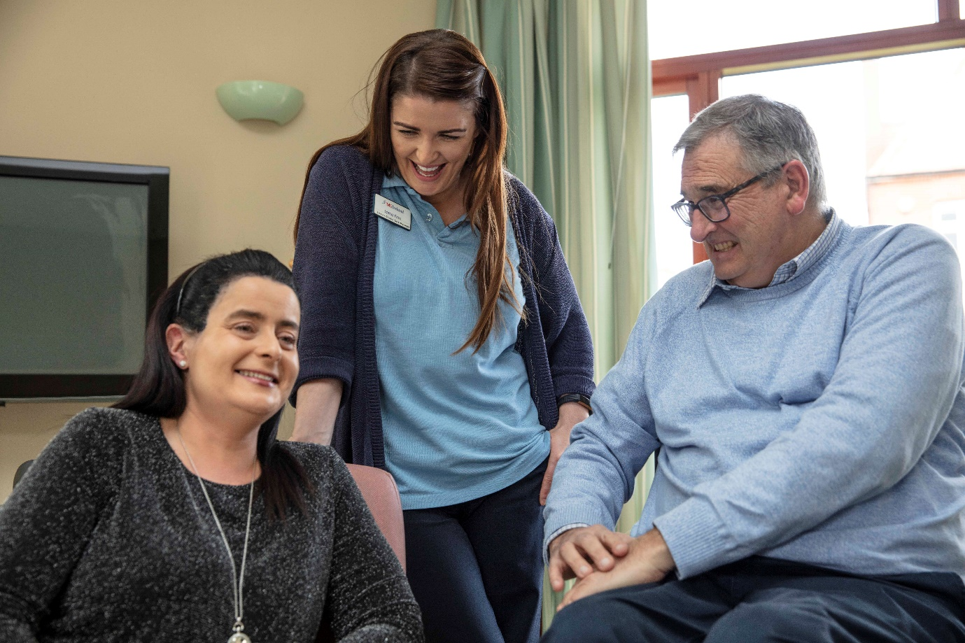

“I know from the moment I go inside that door, I am cared for instantly, my worries go away from the moment I go in that door, they take my bags, make sure I am ok, provide me with food and tea, it’s a safe place to go, you feel happy knowing that everyone there is looking after you” Edel
“My late wife had MS too. We never got to go on a honeymoon but when we came in here she said to me this was our honeymoon.” Martin

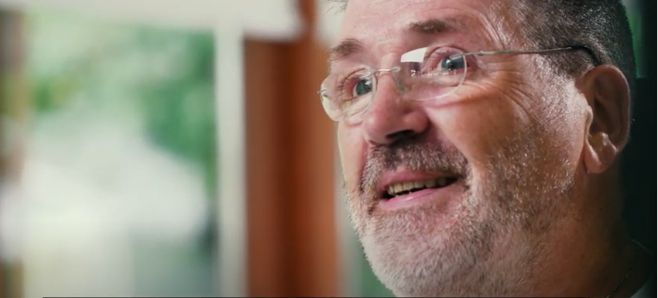

“When I met with the nurse specialist, she goes through all of my medications, my home situation, aids, facilities etc. and may make suggestions and recommendations for me. My life is so much better having access to a nurse specialist and going forward everyone should have access to one. I feel nurse specialists are crucial for people with neurological conditions” Mark

